AWS CLOUD COMPUTING CURRICULUM

- IAM – Identity Access Management
- EC2 – Elastic Compute Cloud
- S3 – Simple Storage Service (Data Lake Service)
- RDS – (Relational Database Service)
- DynamoDB (NoSQL DB service)
- Redshift (Data Warehousing Service)
- AWS Glue (ETL & ELT Service)
- AWS Athena (Big Data /Data Warehousing Service)
- Snowflake Fundamentals (Data Warehousing Service)
- AWS Lambda
- AWS Kinesis (Streaming Service)
- GenAI Fundamentals

Relational DB Service , NoSQL DB service , difference between the first two , what is traditional data warehousing service, what is advanced data warehousing concepts / architecture , what ETL & ELT Service, what is Data Marks, what is Data Lake, what is Data Governance

Structure & Schema:
BOTH Mandatory for STRUCTURED
St is Mandatory and Sc is not for SEMI_STRUCTURED
None of the above Mandatory for UNSTRUCTURED

Four main types of NoSQL :
- Key-Value pair

Features:
Fast key-based lookup
Ex- Redis, DynamoDB
Best for Caching, Sessions

- Document

Features:
JSON/BSON flexible schema
Ex- MongoDB, CouchDB
Best for Webapps, Catalogues, CMS

- Column-Family

Features:
Wide columns, big data scaling
Ex – Cassandra, HBase
Best for Analytics, Time-Series

- Graph

Features:
Nodes + edges + relationships
Ex - Neo4j, Neptune
Social, Fraud, Recommendations

Cloud Computing is a platform that delivers on demand IT resources, over the Internet by using pay-as-you-go model. In simple terms, CC allows businesses and developers to rent computing services instead of buying and maintaining a physical service.

Advantages:
On demand Self-Service
Scalable and Elastic
Pay only for usage
Global Access

IAM : Identity & Access Management

It is a PaaS (Platform as a Service) based security service that helps you to control, who can access what services in your AWS account. By using IAM, you can create and manage users, groups, permissions., roles and security policies.

AWS Certified Data Engineer Associate 2026 - Hands On!
211-215 ( continue to 218 for Final Viva )

Data Engineer on AWS – The complete training

IAM imp topics – Roles, Users and Policies

EC2 : Elastic Compute Cloud 2

EC2 is an IaaS ( Infrastructure as a Service ) . IaaS means that the cloud computing is responsible for giving us the hardware to run a virtual operating system. It is a regional service; we can select region as opposed to IAM which is a global service.

It is a compute service, which provides compute resources over the internet, and it can extend or shrink based on requirements.

Elastic – We can extend and shrink depending on requirements.
Compute – refers to compute components that are required to run a computer
Cloud – Servers are running in local machines, Infrastructure required to run the virtual OS exists in remove data centres.
To deploy EC2 instance in console, there is a 7-step procedure:

STEP 1: AMI ( Amazon Machine Image ) & Amazon Marketplace
Like ( .apk and Google Play Store distinction )
An AMI is a pre-configured template containing OS + software used to launch EC2 instances.
AWS Marketplace is an online software store where customers can find, buy, and instantly deploy software on AWS.

Model | What You Manage | What Cloud Manages
IaaS | OS, apps, middleware | Hardware, network, virtualization
PaaS | Apps only | OS + infra
SaaS | Nothing | Everything (ready-to-use apps)

Golden image- Backup of entire OS along with applications and data. Running copy of an OS. OS template. In amazon terms it is called AMI.
Instance type and family-
There are six categories of instance types available in EC2 – general purpose, compute optimized, memory optimized, storage optimized, accelerated optimized, HPC optimized.
General purpose: t2.micro ( n CPU , 2n RAM )
Memory optimized:
Compute Optimized:
Storage optimized : SSD available
STEP 2: ALWAYS GO FOR t2.micro ( 1GB RAM ) or t3.micro

Feature | t2.micro | t3.micro
vCPUs | 1 | 2
RAM | 1 GiB | 1 GiB
CPU Mode | Standard (Unlimited optional) [cloudzero.com] | Unlimited by default [cloudzero.com]
Baseline/Burst | Older credit system | More efficient credit system
Network | Low–Moderate source | Up to 5 Gbps source
Price | $0.0116/hr | $0.0104/hr
CPU Architecture | Older Intel (Haswell/Broadwell) | Newer Intel (Skylake/Cascade Lake)
STEP 3: Login Mechanism
Symmetric and Asymmetric Login
First one is with the help of pre shared key, like “clear text” passwords.
Second one is public key private key combination. We can overcome security flaws like MITM attacks. By default, AWS EC2 recommends going with Asymmetric login base mechanisms, that is PP key combos.

STEP 4: Public and Private IP
In Amazon EC2 console, whatever instances we deploy, will get a public IP and a private IP.
Public IP is used for internet-based communications, it has global identity.
Private IP is used for internal comms inside Amazon network.

Selecting region – Latency > Customer Trust > Cost

FOR LINUX MACHINES: Only CLI supported , also same key pair can be reused.
SECURITY GROUP (SG):
- In AWS, it is a virtual firewall that controls traffic to and from resources like EC2 instances.
- Think of it as a set of rules that decide what goes in and what comes out.
- If it’s a regional service, everything comes under VPC ( Virtual Private Cloud ). Under VPC there is a set of security rules we can configure , that is nothing but ACL ( Access Control List. )
- There is a service level security available for every service, for EC2 it is called as SG.
- Traffic travels in the following sequence
- Local machine -> VPC -> ACL -> SG (Service level Firewall) -> VM

S3 : Simple Storage Service
- It comes under PaaS (Platform as a service) model.
- It comes under Object Oriented Storage Service.
- Considers everything as object.
- Buckets is a top-level container where we can dump all corresponding objects
- For bucket naming we follow certain rules and regulations : Must be globally unique, bucket names must be min 3 characters and max 63 characters, will accept certain special characters only , MUST NOT RESEMBLE IP ADDRESSES
- Buckets don’t have any kind of size and file type limitations, but objects do have in terms of size, 50 TB.
- Objects inside the buckets are accessed by a unique HTTPS.
- If we want to unblock the object to public access ( access denied by default ), the following 2 step procedure is to be followed – Go for bucket level, under permissions turn off block public access. Make sure ACL is enabled in ownership. Lastly go to object level and under object actions , make public using ACL.

Features:
- Versioning control keeps track of various versions of the bucket, so any accidental deletion can be avoided. Rollback option.
- Version before enabling of versioning will get ‘Null’ as version id, post that every subsequent version will get its own unique version id.

STATIC HOSTING on S3:
- Properties -> S3 static web hosting

S3 Storage Classes:
There are eight different storage classes available in S3:
- Standard ( default ) : For S3 Standard, 3 availability zones
Bucket Lifecycle Policy
There are 3 ways available to access AWS services:
- Amazon Web Console
- AWS CLI
- AWS SDK – Python BOTO3 library, a way to interact with AWS console.

RDS (Relational Database Service):

- RDS comes under regional service module
- It is a PaaS model ( no OS or software maintenance )
- There are six main flavours of relational databases supported by RDS
MySQL, Microsoft SQL, MariaDB, PostgreSQL, Oracle, IBM Db2 .
- Amazon Aura, Amazon Aura Postgre Compatible.
- DB Instance - Free Tier only
- db.t4g.micro for MySQL
- Three groups – Subnet group, parameter group, optional groups

AWS REDSHIFT – DATA WAREHOUSING

- Amazon Redshift is a PaaS based data warehousing architecture, that totally depends on PostgreSQL
- It is a cluster-based data warehousing architecture, that is supported for horizontal scaling
- We can provision our RedShift Cluster by two ways – Serverless and User Provisioned Model.

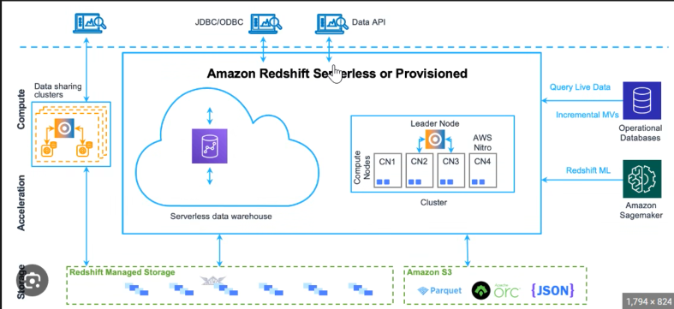

- Supported for internal and external volumes
- Costliest service, per hour billing is $5 to $6 / hour

Features:

- Serverless :
There are two key technologies, namespace and workgroup.
Namespace is the logical data container where your databases live, along with it’s schema tables user roles metadata and its storage information. It represents the data and security, not the compute medium. It is equivalent to database environment and its storage layer.

Workgroup represents the compute resources, think of it as a query execution engine, RPU (Redshift Processing Unit). Performance and Scaling behaviour. Network and it’s endpoint.
Node types:
Ra3.large
Ra3.xlplus
Ra3.4xlarge
Ra3.16xlarge

Starting a Redshift Cluster and connecting from EC2 Instance
Step 1: North Virigina Region, create redshift cluster from console. Node number should be 1 , Node type : Re3.large, choose username, password. Don’t Register with Glue Data Catalogue
Step 2: Make S3 Bucket
Step 3: Create IAM Role for Redshift with ‘S3FullAccess’
Step 4: Make Cluster public access
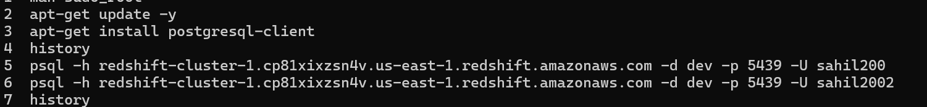
Step 5 : SSH into EC2 Instance
Step 6: Connect to Cluster via PostgreSQL ( last step )
Step 7: Add Redshift to Inbound Rules of Cluster SG
Step 8: Go to Properties , Associate IAM role created in Step 3 to the Cluster
By default, will use Internal Storage , 1TB given by default. RedShift Provisioned Volume
External : S3 bucket

Step 1:

SparkStreaming
Step1: Create a DriverContext
Step 2: Create object of driver context

How to Unload data from RedShift to S3
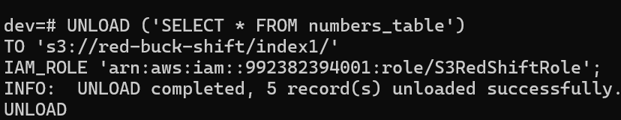

RedShift Distribution ( explore )

DYNAMO DB

- It is a service, that comes under NoSQL DB type.
- To maintain the standard in NoSQL, they came up with different standard named as CAP theorem. C: Consistency A: Availability P: Partition Tolerance
- To understand CAP, all NoSQL DB , by default support horizontal scalability.
- Dynamo DB came up with two types of consistency : Strong Consistent and Eventually Consistent

EVENTUAL CONSISTENT :

Eventual consistency means that your read may return stale data — it might not reflect the most recent write.
This happens because writes are replicated asynchronously to multiple nodes.
According to AWS:
- Eventually consistent reads are the default for all DynamoDB tables. [docs.aws.amazon.com]
- A read may not show a recent write, but “if you repeat your read request after a short time, the response should eventually return the more recent item.” [docs.aws.amazon.com]
- They work on tables, LSIs, GSIs, and streams. [docs.aws.amazon.com]
- They cost half as much as strong reads. [docs.aws.amazon.com]

STRONG CONSISTENT:

Strong consistency ensures that your read returns the most recent committed write, across all replicas.
From AWS documentation:
- If ConsistentRead = true, DynamoDB returns “the most up-to-date data, reflecting updates from all prior successful write operations.” [docs.aws.amazon.com]
- Strong consistency is only supported on tables and LSIs (NOT GSIs or streams). [docs.aws.amazon.com]
How it works:
- DynamoDB ensures the read is served from the leader node, which always has the latest update.
- Secondary replicas may lag slightly due to async replication — which is why strong reads must avoid them.
[repost.aws]
In simple words:
Always correct, always latest — but slower and more expensive.

- In DynamoDB ,by means of billing they came up with read or write unit.
- RCU and WCU determine billing , Read and Write Capacity Units respectively.
- Strong Consistent, it will read up to 4KB ( max capacity ). Eventually Consistent, it will do for the same 4 KB, it will do two reads. ( double efficient but half as reliable )

- Tables made up of Partition key ( primary ) and Sort Key . So optionally can make just partition or a composite key with combination. Partition key is generally a hash.
- P
- Sort Key: we can use this as a second part of table’s primary key ( composite key/super key ) , and it allows us to sort or search among all the items sharing the same partition.
- 8 CPU = 8 Node slices in cluster . It is for row – wise sorting
- HOW TO CREATE AND MANAGE DYNAMO DB USING PYTHON SDK AND AWS CLI
( Advanced )
HOW TO IMPLEMENT LSI AND GSI IN DYNAMO DB
WHAT IS MEANT BY DAX
WHAT IS MEANT BY DYNAMO DB STREAMS
HOW TO HANDLE TTL

HOW TO INSTALL PYSPARK AND JUPYTER NOTEBOOK ON EC2 FOR PROJECT.
HOW TO INSTALL POWER BI ON EC2
ALWAYS GO FOR LINUX UBUNTU

HOW TO STREAM DATA TO S3
HOW TO CONNECT S3 to SNOWFLAE
HOW TO QUERY STREAMED DATA using snowflake

AWS GLUE
- AWS Glue is a serverless data integration service , that is used to discover , prepare, move and integrate data for analytical work, machine learning and application development.
- It is mainly used for ETL and ELT pipelines in AWS ecosystems.

Core Components of AWS Glue:
- AWS Glue Data Catalogue :
  - It’s a central repository for handling metadata.
  - We can create one data catalogue per region
  - We can integrate these data integration services to run Glue Jobs, Redshift and Athena related services.
- Glue Crawlers:
  - It will automatically scan the data from multiple data sources and
Infer Schema.
- Glue Jobs:
  - It will run your ETL and ELT jobs
  - To do so, it will use Apache Spark Serverless Clusters
  - It is supported for multiple languages such as PySpark, Scala and SparkSQL
- Glue Studio:
  - It is a visual drag and drop interface to create and manage ETL and ELT jobs.
  - It can monitor the jobs for Success and Failure status.
- Glue Workflows:
  - It can orchestrate and handle multiple jobs at once.
Serverless = Pay for Volume Based , else time based billing

Can’t make Glue Job without data catalogue
Also crawler need for which IAM and S3 bucket needed
3 ways to create etl – software based, coding, and drag and drop
To run Glue Job , 4 different worker types
G1 x
G2 x
G4 x
G8 x

